WIPRO TALENTNEXT PROGRAM
PBL HANDS-ON ASSIGNMENT
Name: M.VINAY
Roll No: 23BQ1A4951
PBL ID:DB_262790141
Date: 14-07-2026
Topic: Introduction to SQL( Aggregated data)

1 & 2. Find the highest, lowest, sum, and average salary of all employees. Label columns Maximum, Minimum, Sum, and Average. Round to nearest whole number.
Ans
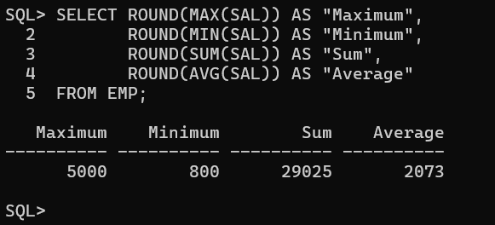
3. Modify to display min, max, sum, and average salary for each job type.
SELECT JOB,
ROUND(MIN(SAL)) AS "Minimum",
ROUND(MAX(SAL)) AS "Maximum",
ROUND(SUM(SAL)) AS "Sum",
ROUND(AVG(SAL)) AS "Average" FROM EMP GROUP BY JOB;
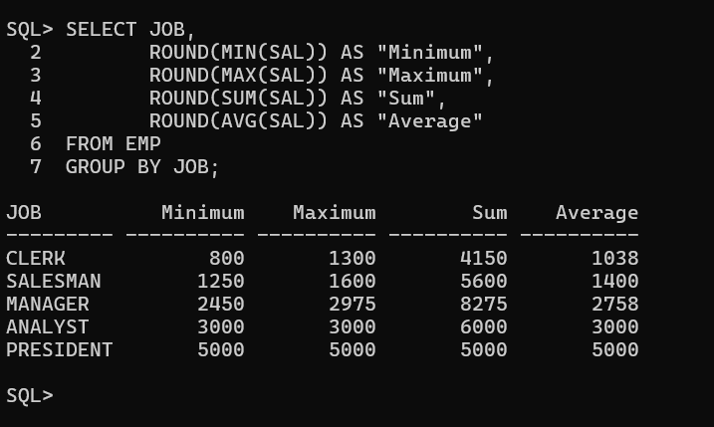
4. Display the number of people with the same job.
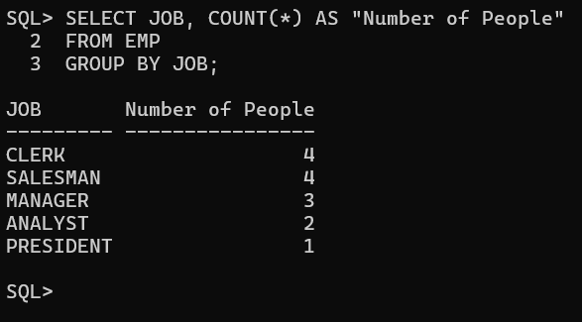
5. Determine the number of managers without listing them, label Number of Managers.
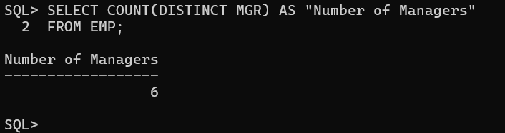
6. Find the difference between the highest and lowest salaries, label DIFFERENCE.
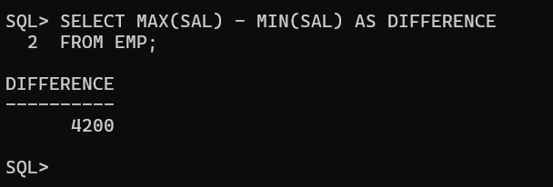
7. Manager number and salary of the lowest-paid employee for that manager. Exclude unknown managers. Exclude groups where minimum salary ≤ $2000. Sort descending by salary.
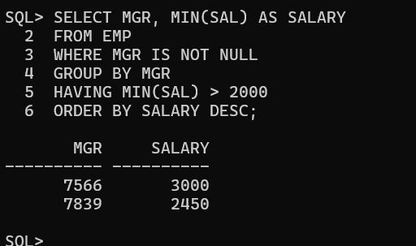
8. Total number of employees and, of that total, the number hired in 1980, 1981, and 1982.
